The French Revolution
Packet #3

Background

- In the 1700s, France was considered the most advanced country of Europe.

  - ________________________________________
  - ________________________________________
  - ________________________________________
  - ________________________________________

Despite these advancements, the appearance of success was deceiving.

- Great unrest in France

  - ________________________________________
  - ________________________________________
  - ________________________________________
  - ________________________________________

Causes of the French Revolution
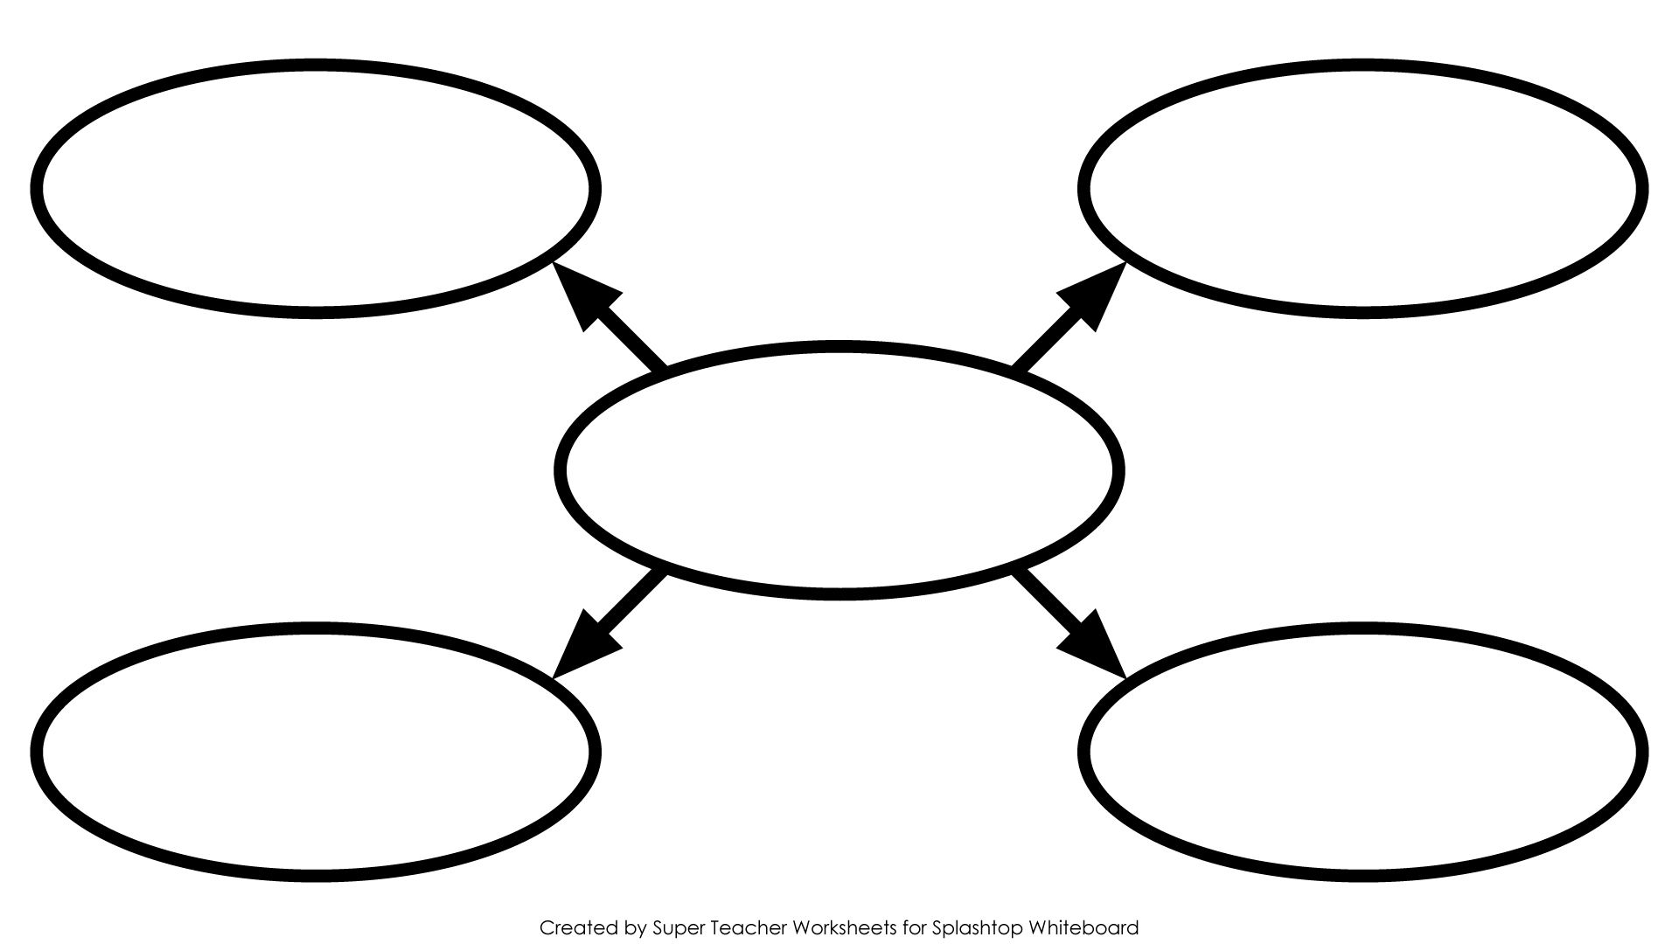

- The Class System: The Old Order

France (1770s) operated under the social and political system of the Old Regime. Under this system the people of France were divided into 3 social classes or estates.

    - The First Estate
Approximately 3% of the population – privileged
      - _____________________________________________
    - The Second Estate
      - _____________________________________________

    - The Third Estate
      - _____________________________________________
        - ______________________________________________
97% of population – had no power to influence government
          - _____________________________
          - _____________________________
          - _____________________________
          - _____________________________
        - ______________________________________________
        - ______________________________________________

- What was the problem with the estate system? ________________________________________

Estate | Income Taxes Paid
First
Second
Third

Results:

- New Ideas about Government
  - _____________________________________________________________________________
_____________________________________________________________________________
_____________________________________________________________________________
  - _____________________________________________________________________________
_____________________________________________________________________________
_____________________________________________________________________________

- Economic Troubles
  - Heavy taxation made it difficult for members of the Third Estate to conduct business profitably.
  - Cost of living was increasing
  - Bad weather in the 1780s caused severe crop failures
    - _____________________________________________________________________
  - Extravagant spending by King Louis XVI and his wife Marie Antionette
  - American Revolution
    - _____________________________________________________________________
_____________________________________________________________________
_____________________________________________________________________
- Weak Leadership
  - Louis XVI was very indecisive and poorly trained for his role as king. He let his wife interfere with government decisions and purchase lavish items.
  - Once Louis XVI decided to make changes, it was too late. He decided to tax the nobility to solve his economic problems.
    - What was the nobles’ reaction to Louis XVI’s tax proposal? _______________________
________________________________________________________________________
________________________________________________________________________
________________________________________________________________________
    - Meeting of the Estates-General - _____________________________________________
________________________________________________________________________
________________________________________________________________________

Background of the Estates-General
The clergy and the nobles (First and Second Estates) dominated the Estates-General throughout the Middle Ages and were expected to do so in the 1789 meeting . Why? Under the assembly’s medieval rules, each estate’s delegates met in a separate hall to vote, and each estate had one vote. The two privileged estates could always outvote the Third Estates.

Dawn of Revolution
- The National Assembly
  - Obvious problems with the voting system of the Estates-General prompted members of the Third Estate to desire to make changes.

  - A proposal: Members of the bourgeoisie (shaped by the Enlightenment) insisted that all delegates get a vote, not a collective vote of the Estate. Why would the Third Estate propose this? ______________________________________________________________________
___________________________________________________________________________
___________________________________________________________________________
___________________________________________________________________________

  - Rejection of Proposal: ________________________________________________________
___________________________________________________________________________
___________________________________________________________________________

  - National Assembly Established _________________________________________________
___________________________________________________________________________
___________________________________________________________________________
___________________________________________________________________________

  - July 17, 1789 ________________________________________________________________
___________________________________________________________________________
    - End of _____________________________________________________
    - Beginning of ________________________________________________

*** This vote was the __________________________________________________________

  - Result of the National Assembly’s Establishment
___________________________________________________________________________
___________________________________________________________________________
___________________________________________________________________________
The Tennis Court Oath - _______________________________________________________
___________________________________________________________________________
___________________________________________________________________________
___________________________________________________________________________

  - Storming the Bastille, Declaration, and the Great Fear
    - Citizens fear that Louis would resort to using military force to break up the National Assembly so they begin to gather weapons for retaliation.
    - July 14, 1789 - ____________________________________________________________
________________________________________________________________________
________________________________________________________________________________________________________________________________________________
*** Bastille Day is still celebrated in France today on July 14.
    - The “Great Fear” results: A great panic rose through France resulting in widespread unlawfulness including peasants retaliating and burning down manor houses.

    - August 1789 – Old Regime Ends
________________________________________________________________________
________________________________________________________________________
________________________________________________________________________
(Influenced by the Declaration of Independence, the document states that “men are born and remain free and equal in rights.” These rights included __________________,
________________, ________________, and __________________________________

    - October 1789 – A group of women (thousands) stormed Louis XVI’s palace armed with axes, knives, and other makeshift weapons in response to rising bread prices. Rumors were that the king and queen were stockpiling grain. The women killed several guards and forced the king and queen to leave the palace. ______________________________
________________________________________________________________________
________________________________________________________________________
________________________________________________________________________

Divisions Develop
For two years, the National Assembly argued over a new constitution for France. By 1791, the delegate’s had made significant changes in France’s government and society.
- A limited Monarchy
________________________________________________________________________________
________________________________________________________________________________
________________________________________________________________________________
________________________________________________________________________________

- Legislative Assembly
________________________________________________________________________________
________________________________________________________________________________
________________________________________________________________________________

Despite the “new government” old problems still persisted such as food shortages and debts. The question on how to handle these problems caused the Legislative Assembly to split into three general groups: _______________________, _______________________, _________________________.

Radicals
Moderates
Conservatives

War and Execution
- Monarchs and nobles in many European countries watched the changes taking place in France with alarm. They feared similar revolts. As a result, some countries took action. Austria and Prussia urged France to restore Louis XVI as absolute monarch or face consequences. The Legislative Assembly responded by declaring war in April 1792.
- By the Summer of 1792, Prussian forces advanced on Paris. On _________________________________, a mob massacred the royal guards and imprisoned Louis, Marie Antionette, and their children were imprisoned.
- The September Massacres
- Results: Under pressure from the radicals in the streets and among its members, the Legislative assembly set aside the Constitution of 1791.
  - Called for the election of a new legislature
    - A new governing body, __________________________________________ took office on ________________________________________.
      - _________________________________________________________
      - _________________________________________________________
- The National Convention - _____________________________________________________________
___________________________________________________________________________________
  - They tried Louis XVI for treason, found him guilty, and sentenced him to death

  - January 21, 1793 - ______________________________________________________________
_____________________________________________________________________________
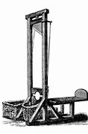

        - The National Convention also had to contend with the continuing war with Prussia and Austria. Early in 1793, ________________________________,
_________________________________, and ______________________ joined the war against France.

        - France ordered a military draft of citizens between the ages of 18-40 including women to grow their army.

The Reign of Terror
- In the early months of 1793, Maximilien Robespierre slowly gained power. Robespierre and his supporters set out to build a “_____________________________________” by wiping out every trace of France’s past.
  - Calendar changed
    - ________________________________________________________________________________________________________________________________________________

  - Churches closed
    - ________________________________________________________________________________________________________________________________________________

- Robespierre became leader of ______________________________________________ in July 1793.
  - Basically rules as a _________________________________________________
  - His rule becomes known as __________________________________________

- Committee of Public Safety
  - Chief task
    - ________________________________________________________________________
________________________________________________________________________

  - Guillotine
    - ________________________________________________________________________________________________________________________________________________

    - ________________________________________________________________________
________________________________________________________________________

    - ________________________________________________________________________
________________________________________________________________________

- The End of the Terror
  - July 1794
    - ________________________________________________________________________
________________________________________________________________________

  - July 28, 1794
    - ________________________________________________________________________
________________________________________________________________________

  - 1795 – A third form of government established since 1789
    - The Directory
      - ____________________________________________________________________________________________________________________________________
__________________________________________________________________

- Napoleon Bonaparte
      - ____________________________________________________________________________________________________________________________________
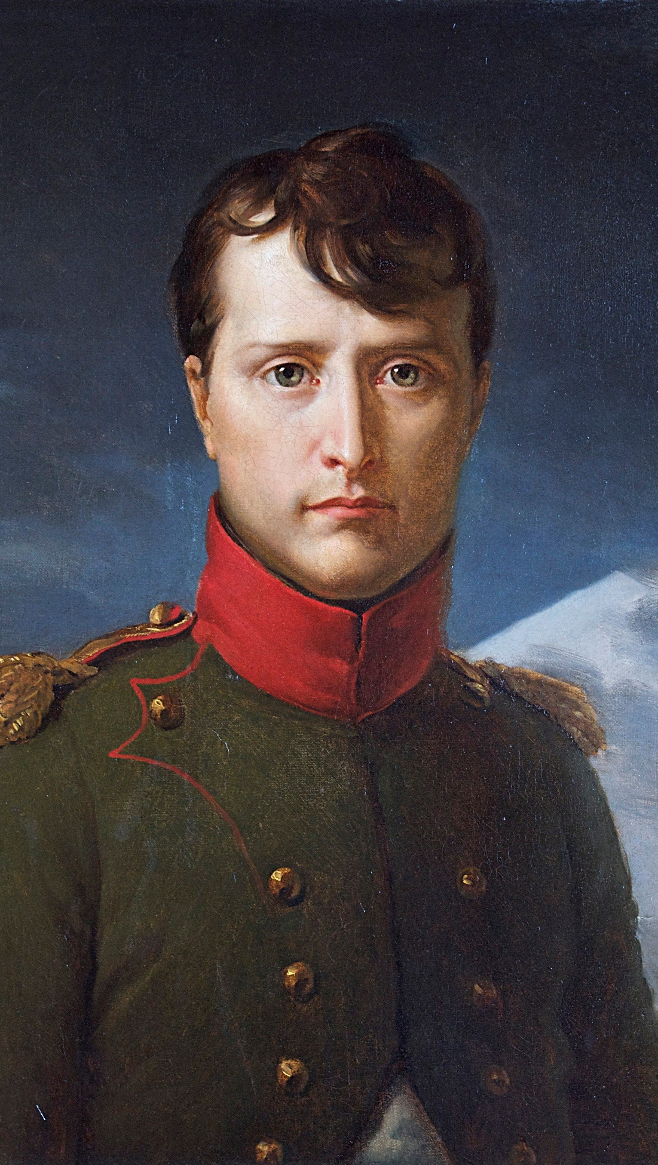

__________________________________________________________________

      - ____________________________________________________________________________________________________________________________________
__________________________________________________________________

- ________________________________________________________________________________________________________________________________________________________________________

- ________________________________________________________________________________________________________________________________________________________________________

- ________________________________________________________________________________________________________________________________________________________________________
Napoleon’s Empire Collapses
- Napoleon’s own personality proved to be the greatest danger to his empire. His desire for power raised him to great heights, but also led to his doom. In his efforts to take control of Great Britain, Napoleon made three costly mistakes:
- The Continental System – a blockade system set up by Napoleon in an effort to cut off Great Britain from other European countries.
- The Peninsular War
- Invasion of Russia
- Napoleon’s enemies were quick to take advantage of his weakness. __________________________, _____________________, _____________________, and _________________________ joined forces against him. In addition _______________________ declared war against France as well.
- By April of 1814, Napoleon accepted terms of surrender and gave up his thrown.
- Napoleon was exiled to _____________________, a tiny island off the coast of Italy.
- Louis XVI’s brother ____________________________ assumed the throne but he was not well received by the people. This was the news Napoleon wanted to hear. He escaped from Elba on ________________________________. Within days he was restored as emperor.
- In response to Napoleon’s return, the European allies quickly marshalled their armies. After a battle at Waterloo, Napoleon’s troops were defeated. This defeat ended Napoleon’s last bid for power, called the ______________________________________. Taking no chances, the British exiled Napoleon to ________________________, a remote island in the South Atlantic. He died in __________________.
- Napoleon was a military genius and brilliant administrator. Yet all his victories and other achievements must be measured against the millions of lives lost in his war. It was once said of Napoleon that “ He was as great as a man can be without virtue.”
- Results:

The Congress of Vienna
- European heads of state were looking to establish long-lasting peace and stability on the continent after the defeat of Napoleon. A series of meetings in Vienna, known as the Congress of Vienna, were called to achieve this goal. Most of the decisions were made by the “five great powers” - ______________________________, _________________________, _________________________, ______________________________ and ___________________________.
- Led by Prince Klemens von Metternich, foreign minister of Austria, three goals were established at the Congress of Vienna:
- __________________________________________________________________________
__________________________________________________________________________
__________________________________________________________________________
__________________________________________________________________________

- __________________________________________________________________________
__________________________________________________________________________
__________________________________________________________________________
__________________________________________________________________________

- __________________________________________________________________________
__________________________________________________________________________
__________________________________________________________________________
__________________________________________________________________________

- The Congress of Vienna was a political triumph in many ways.
- __________________________________________________________________________
__________________________________________________________________________
- __________________________________________________________________________
__________________________________________________________________________
- __________________________________________________________________________
__________________________________________________________________________

